Ghazali Chapters 21 and 22

Core Lesson: We can imagine our spiritual hearts like a heart we have drawn and the dots on it symbolise problems I need to correct such as envy which eats up good deeds like fire devouring wood. Please refer students to pages 167-9 of the workbook where they can find references from the lesson and elements of the plan.
Read Chapter 21. There is a lot to cover in the lesson so go straight into the chapter and discuss very briefly.
Activity: students draw their own heart and use different coloured dots to symbolise some of their bad habits/ traits/ vices (whatever word they understand best). For example anger might be red, envy -green, lying- black etc. Use gold glitter glue to trace the outline if possible to show how our hearts are essentially good.
Read Chapter 22 and briefly discuss. The antidote to envy (for younger children the opposite) is to be genuinely grateful for what blessings we have. Older children may understand the idea that envy is like a poison that can take over our hearts.
Connecting to the Hadith: Anas ibn Malik reported that Rasul Allah said ‘Envy consumes good deeds just like fire burns wood. Charity extinguishes sinful deeds just as water extinguishes fire. Prayer is the light of the believer and fasting is his shield from Hellfire.’ (Sunan Ibn Maja 4208)
Teachers’ Role Play: have a list of good deeds pegged to our clothes or placed on the floor/ table or pegged to a string so children can see and remove them. Role play two teachers getting on but then one develops envy for the other. The children walk up in turn and put a good deed in the fire (bin decorated as fire) as they notice an example of envy. See page 168 of the workbook for full details.
How to turn envy into something positive:
- Someone is better looking than me- Allah may have tested them in a different way and they may get unwanted attention (suitable for older children)
- Someone has a better house- they will have more cleaning to do and their parents might have to work harder to pay for the house and have less time with the children
- Someone is better than me at football- they may not be as good as you at Lego for example or anything else
- Someone is allowed to eat lots of treats – they may become unhealthy or have bad teeth.

Conclusion: finish with the egg seller’s story if there is time or leave this till next week. Students can share things they are really grateful for in their lives.

The Egg Seller’s Story
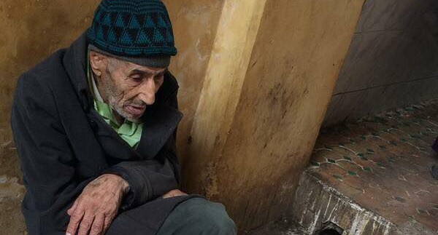

She asked him, 'How much are you selling the eggs for?'
The old seller replied, 'Rs.5/- an egg, Madam.'
She said to him, 'I will take 6 eggs for Rs.25/- or I will leave.'
The old seller replied, 'Come take them at the price you want. May be, this is a good beginning because I have not been able to sell even a single egg today.'
She took the eggs and walked away feeling she has won. She got into her fancy car and went to a posh restaurant with her friend. There, she and her friend, ordered whatever they liked. They ate a little and left a lot of what they ordered. Then she went to pay the bill. The bill cost her Rs.1,400/-. She gave Rs. 1,500/- and asked the owner of the restaurant to keep the change.
This incident might have seemed quite normal to the owner but, very painful to the poor egg seller.
The point is: why do we always show we have the power when we buy from the needy ones? And why do we get generous to those who do not even need our generosity?
I once read somewhere:
'My father used to buy simple goods from poor people at high prices, even though he did not need them. Sometimes he even used to pay extra for them. I got concerned by this act and asked him why does he do so? Then my father replied, "It is a charity wrapped with dignity, my child”

