Ghazali Chapter 15

Lesson Objective:
.
To understand what is meant by awareness, self-observation and self-correction. An imaginary story about two wolves is helpful. One is naughty, the other is good. If one listens to what the naughty wolf suggests, it is like feeding him. If one ignores this wolf, it starves and goes away. The good wolf is nourished and remains.
Read the chapter and discuss
Connecting to the Quran Discussion

Read Surah 114, and reflect upon its meaning:
Say, “I seek refuge with the Sustainer of humankind, the Sovereign of humankind, the God of humankind, from the mischief of the slinking whisperer who whispers in the hearts of human beings
among jinn and among humankind.”

Activity

Reception and Year 1: put two pictures of a good and bad wolf on the board. Read out a series of statements and children take turns to feed the appropriate wolf.

Year 1 can complete the song on page 53 of the workbook.

Years 2-6 complete pages 50-53 of the workbook. There are lots of activities here and pictures to annotate so some may be more suitable than others for your class.

Students make a resolution about which wolf they will feed. Older children can add to their learning journals.

Plenary

Older children can start to recite and memorise the following dua. Younger children can listen or do other dhikr or listen to a nasheed/poem.

https://authentic-dua.com/2011/12/10/duaa-of-light-noor/

Du’aa of Light (Noor)
Invocation for going to the Masjid
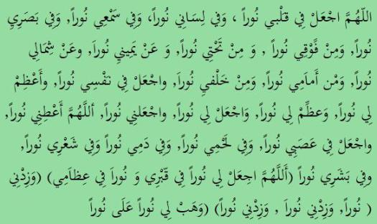
Allaahummaj’al fee qalbee nooran, wa fee lisaanee nooran, wa fee sam’ee nooran, wa fee basaree nooran, wa min fawqee nooran, wa min tahtee nooran, wa ‘an yameenee nooran, wa ‘an shimaalee nooran, wa min ‘amaamee nooran, wa min khalfee nooran, waj’al fee nafsee nooran, wa ‘a’dhim lee nooran, wa ‘adhdhim lee nooran. Waj’al lee nooran, waj’alnee nooran. Allaahumma ‘a’tinee nooran, waj’al fee ‘asabee nooran, wa fee lahmee nooran, wa fee damee nooran, wa fee sha’ree nooran, wa fee basharee nooran.[1]
[Allaahummaj’al lee nooran fee qabree, wa nooran fee ‘idhaamee.][2]
[Wa zidnee nooran, wa zidnee nooran, wa zidnee nooran.][3]
[Wa hab lee nooran ‘alaa noor.] [4]
O Allah, place light in my heart, and on my tongue light, and in my ears light and in my sight light, and above me light, and below me light, and to my right light, and to my left light, and before me light and behind me light. Place in my soul light. Magnify for me light, and amplify for me light. Make for me light, and make me light. O Allaah, grant me light, and place light in my nerves, and in my body light and in my blood light and in my hair light and in my skin light.[1]
[O Allaah, make for me a light in my grave… and a light in my bones.] [2]
[Increase me in light, increase me in light, increase me in light.] [3]
[Grant me light upon light] [4]
Listen / Download Mp3:
Audio Player
00:00
00:00
Use Up/Down Arrow keys to increase or decrease volume.

[1] Up to this point was reported by Al-Bukhaari 11/116 (Hadith no. 6316) and by Muslim 1/526, 529-530 (Hadith no. 763)
[2] At-Tirmidhi 5/483 (Hadith no. 3419)
[3] Al-Bukhaari in Al-‘Adaab Al-Mufrad (Hadith no. 695), p. 258. See also Al-Albaani, Sahih Al-‘Adab Al-Mufrad (no. 536)
[4] Al-Bukhaari, cf. Al-Asqalaani, Fathul-Baari 11/118
It is one of the Supplications Prophet (Peace be upon him) used to supplicate in Sujood
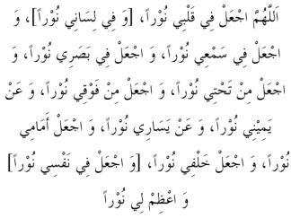
«O Allaah! Place light in my heart; [and light in my tongue;] and place light in my hearing; and place light in my seeing; and place light from below me; and place light from above me, and light on my right, and light on my left; and place light ahead of me; and place light behind me; [and place light in my self;] and make the light greater for me»[125]
[125] Muslim, Abu `Awaanah and Ibn Abee Shaybah (12/106/2, 112/1).
Source : The Adhkaar of Sujood – The Prophet’s Prayer Described – from the beginning to the end as though you see it – by Shaykh Muhammad Naasiruddeen al-Albaanee

Feeding the Wolf

- Saying ‘Bismillah’ before eating, drinking or starting any activity.

- Quickly telling someone to hurry up if they are walking slowly

- Sharing your sweets

- Smiling at your neighbour

- Helping your mum with her chores

- Ignoring someone in your class

- Telling someone you will call them later when you don’t really think you will.

- Helping someone who has fallen down

- Not laughing with the group if they are making fun of someone

- Joining in with bullies so they don’t bully you

- Calling your grandparents to keep up relations

- Reading your salah as soon as it is time

- Eating with your right hand

- Not asking Allah for help first

- Thinking you are better than someone else

- Getting angry with your parents when they tell you off

- Making wudu if you feel sad or angry

